New business models and digitalization in Finnish wood products industry

Authors: Minna Komulainen, D.Sc. (Tech), University of Eastern Finland, minnakom@student.uef.fi; Tarmo Räty, D.Sc. (Econ), Researcher, Natural Resources Institute Finland & Thomas Rimmler, MSc. Researcher, Natural Resources Institute Finland

ABSTRACT

Abstract to the 2nd Annual World Open Innovation Conference, University of California, Berkeley, Haas School of Business 19.11.2015

Key words: Business model, Digitalization, Wood products industry, Open innovation

- INTRODUCTION

Today many enterprises are changing their innovation management from a closed to an open innovation model (Chesborough 2011). Open innovation builds upon the collective design and production of goods and knowledge. It enables an organization to leverage new potential for creating and capturing value (Chesborough 2006). Chesbrough and Crowther (2006) found that open innovation model is useful for industrial innovation also in more traditional and mature industries. Wood products industry is an example for mature, product-based industry, which is gradually transforming its business models towards more open network (Pätäri, Puumalainen, Jantunen & Sandström 2011). It is interesting to analyze how digitalization enables or maybe forces companies to that direction.

Digitalization has a profound impact to the business models of an industry (Porter 2001, Porter & Heppelmann 2014, Rajala & Westerlund & Möller 2012). It may open new markets and create new arenas for joint product development, but also disrupt traditional business operations, challenging value-chain and product-dominant logic (Clayton1997). How do traditional industry branches like wood products and furniture industry scope in the age of digitalization? Are they keen on adopting new approaches to their innovation management? Could they benefit from open innovation model?

The study examined Finnish wood products companies from sawmills to furniture producers to see how digitalization has affected their business models. Despite the increasing interest in open innovation research, most studies have focused on large technology-intensive companies. The study gives some insights into impacts of digitalization and business models in micro and SMEs. The selection of the target group was based on the results of the national industrial reviews. Industrial Review of TEM (2014) emphasized that the wood products industry has had a low adoption rate of digitalization, and thus facing high international competition in their internal market, but it also could benefit a rapid increase in their competitiveness through digitalization.

Statistics on Finnish wood products industry in 2012
Number of companies 3 000
Annual turnover 5 600 m€
Employees 28 000
The average size of a company is 9 employees and turnover about 2 million euro.
Main products
Share of Exported
turnover
Sawn or planed wood 52 % 50 %
Plywood or boards 12 % 50 %
Wooden houses 12 % 16 %
Engineered wood 17 % 30 %

Figure 1. Fact box on the wood products industry in Finland, Scandinavia

The variables for the adoption of digitalization among wood products companies were selected according the innovation diffusion theory (Rogers 2003). Besides internal factors, like size, product categories, market area and occupation, the perceived benefits and barriers, also the external network and the business environment may affect to the rate of adoption. Therefore to study the external business environment, the open innovation theory (Chesborough 2003) was applied as an important part of the analysis.

The main research question was how digitalization affects the business models of Finnish wood products industry. What are the barriers of adoption and which kinds of new business options it may promote? The study also searched for scenarios and new business models for wood products industry with the aim of finding potential development platforms and learning solutions.

- METHODS
The data was collected from interviews (N=13) and a online survey (N=31) to which qualitative and non-parametric statistical analyses were applied. As the phenomena of digitalization is transforming rapidly, the research triangulation applied in form of pre-interview and online questionnaire was thought to provide a more profound understanding of the emerging situation in firms. The first phase of the study stated with an interview survey. The majority of 13 interviewees were producers, managers of the companies, logistic companies or from information technology companies or other developers of wood products industry experts.

The online survey was arranged in spring 2015 by email invitation in printed matter, Twitter and Facebook. The questionnaire was divided into four parts: Enterprise data (I); Rate of adoption of digital tools (II); Perceived benefits and perspectives for new business models (III); Impact of digitalization in business-to-consumer (B2C) and business-to-business markets (B2B) and Barriers of adoption (IV). There were 31 persons responding to the survey. The collected data was analyzed through descriptive and testing tools provided in the SPSS software package. Chi-Square, Mann-Whitney and Kruskall-Wallis testing methods were applied.

- RESULTS

3.1 Major changes in wood products market
The interviews provided information on the market situation. The main findings are summarized below in the chapter 3.1. from the perspective of Finnish wood products companies:
1) Market situation within foreign manufacturers and stores. Competitors enter direct to home market either via retails or online stores. The supply of dominating retailers, who manage all the value chain from brick-and-mortar to digital variety, exceeds the possibilities of local producers.
2) Digital marketing is opening the internal markets of EU. Finnish producers have better possibilities to increase the awareness on their products among buyers and consumers in whole EU. Although the competition increases and the buyers are relatively sparser, the enlarging potential market-area creates new possibilities.
3) Need of the product information increases. Especially interior and construction design and sales to end-consumer set new requirements on producing information on the price, but for the digital information on the product, its qualities and usage.
4) Consumer and organizational buying behavior changes. Revolution of digital commerce effects in all market areas, and has increased the meaning of customer experience, brand and social communities. Procurement in public sector requires also digital knowledge. Digitalization offers tools to understand customer’s buying behavior and recognizing their hidden needs and utilize that in marketing, product development and new business models.

3.2 Rate of adoption

The results of online survey is summarized in the following chapters (3.2 - 3.6). As to the rate of adopting digital tools and services 2/3 are applying digital marketing or other digital tools, whereas 1/3 applying none. Results showed differences in adoption behavior among firms of different size and product focus. Sawn and furniture product groups were more often as early adopters of digitalization than building structures product group. Differences were found also between firms focused on local markets and firms operating on export markets. Micro firms in domestic markets perceived themselves more often as late majority or laggards in adoption of digital tools.
The applied digital tools were related to marketing, online retailing, accounting and payments (Figure 2.). 71 % were applying digital marketing tools, of which own internet pages, search engine optimization and social media were the most common. Production (45 %) and financial administration (29%) were applied in forms of online payments, digital invoicing and visitor tracking.

E-commerce in wood products was less common, only 13 % had their own online shop or joined firms’ shared online portal. As almost 70% of respondents were micro or SME’s, Thus they may have less capacity to obtain digital solutions nor platforms for e-commerce.

Only one of the respondents sold directly to the independent online shops, due to producers’ crucial position between brick-and-mortar and online shops. In interviews that big question was raised up, that brick-and-mortar shops may reject producers that sell similar variety online.

Figure 2. Share of the applied tools in respondents’ companies.

3.3 Perceived impacts and benefits

In the question, how the digitalization or its’ consequences have affected to respondents company's business, 55.2 % of respondents stated that digitalization has opened new markets for them. 24.1% mentioned it has supported to defend current markets. Only 6.9 % perceived it to have harmed firm’s position in market. However the amount of answerers, who said that they don’t know, was quite high (14 %).
Digitalization, in general, is seen as an opportunity for the new business models through their value-creating potential. Digital tools and services are being applied mainly on facilitating sales, transactions and information transfer. Firms were not found engaging in new forms of digital marketing collaboration, like participating in joined web portals or more developed peer-to-peer collaborative marketing platforms. Digitalization respondents viewed its impact less important to firms’ downstream supply chain linkages.
The key advantages of digitalization were considered as generating new customers, providing improved customer services, satisfaction, responding to customers demand and increasing sales to current customers.

Figure 3. Perceived advantages of digitalization among the wood products companies.

3.4 Market scenarios in wood industry related to digitalization
The respondents evaluated eight different scenarios , or changes, that digitalization can bring to wood products industry according their importance for their business and probability. The same set of scenarios were presented for the B2B and B2C environments.
The respondents considered digitalization more important for B2B-commerce than for B2C-commerce, although general discussion on meaning of digitalization often refers it’s impacts to customer behavior in consumer markets.
Digitalization has raised the importance of brands especially in B2B commerce. Providing product information digitally was the most important factor in B2C and B2B commerce. Furthermore, the importance of digital platforms was highly valued. The role of online retailing was seen as growing, while multi-channel selling was considered as minor factor in change.
Branding and digitalization as a value creating marketing strategy got minor support among respondents. Respondents' sales are quite often "technical sales" directed to B2B markets", as marketing budget and size of target audience of their firms are also limited.

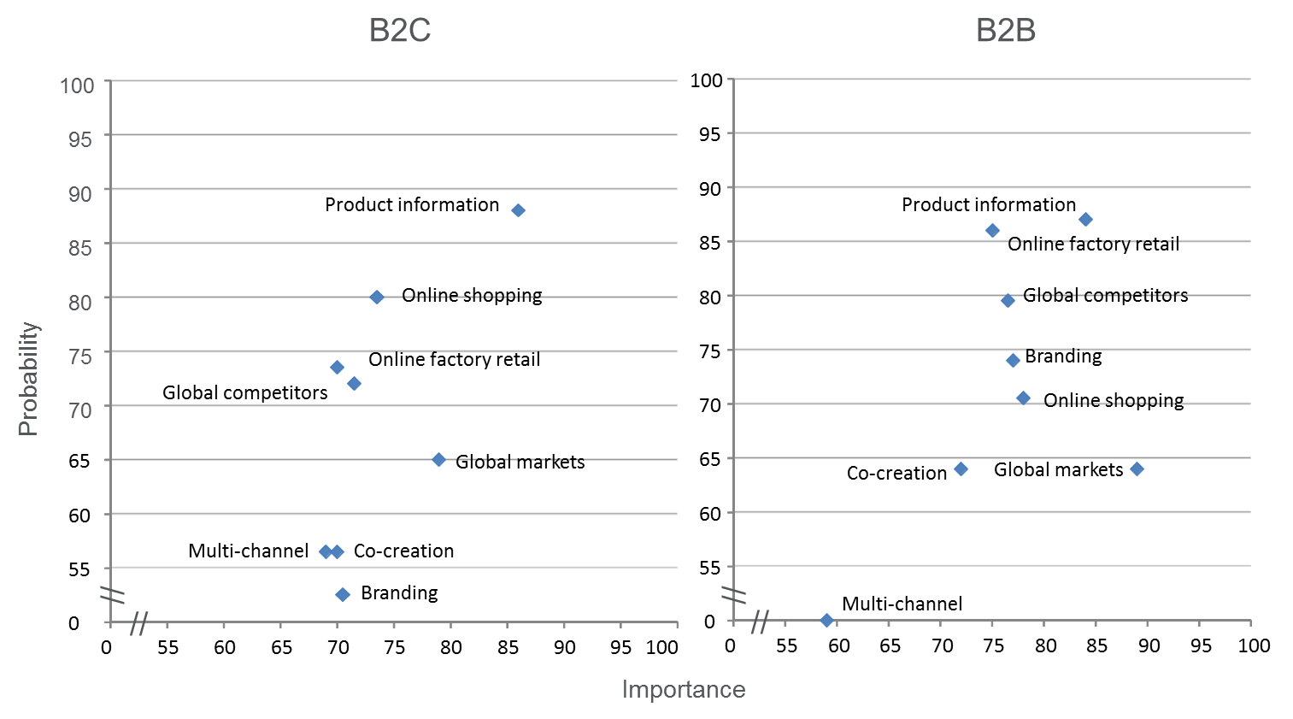
Figure 4. The probability of a scenario and its’ importance to business in B2C (Business-to-Consumer) and B2B (Business-to-Business) market.

3.5 Barriers for adoption
Firm’s internal or external structures may act as a barrier when introducing digital tools. The low profit from IT-investment and the profits not covering the costs was one main barrier mentioned in the study. This was related to the other main barrier, the difficulty of measuring the results.
The other important barriers were related to the lack of information. The respondents did not know which solutions would be best for their company, thought they needed more information or training. They mentioned that they had difficulties in creating added value for their customers with digital services and did not have partners, who could utilize digital solutions.
3.6 New platforms for enhancing learning and open innovation
The results do not fully support the idea that digitalization is an opportunity for a profoundly new approach to value creation. 63 % of the respondents were owners or entrepreneurs of firms. One third of them considered the impact of digital services quite negatively, that in increasing sales or improving customer satisfaction did not meet their expectations. However, gaining new customers though digital platforms was widely supported. Compared to primary and consumer good producers, the mid-stream producers (eg. building elements, doors and windows) were more pessimistic concerning usefulness of digital platforms.
As a concluding remark there is no evidence that digitalization is being viewed or used as an opportunity for creating profoundly new business models among the focal firms of the study. It was found out that the firms are keen on the development, but their lack suitable solutions or good examples to adopt their practices.
The respondents appreciated most the enterprise-specific counselling, perhaps due to the fact that needs of companies may vary. Secondly, learning together was appreciated as well in forms of peer-workshops or training sessions created by industrial organizations.

5. CONLUSIONS
This survey studied the role of technologies in supporting wood industry in their innovation processes. It aimed to examine the level of adoption, main barriers and new innovative arenas needed for joint-development. Although the sample of the survey was small, limiting its reliability, it highlights some important key factors for further development.
Retailing in both traditional brick-and-mortar and online shops was challenging according to respondents. One barrier for online shop business was the question, how to allocate revenues and costs between producers and intermediators. Searching for new business logic may affect to the entire value chain and leave questions to be solved. That may be a reason for why the respondents considered the rise of joint multiple retailing channels unlikely. Best-practices and models from other industry are needed to support the wood industry to benefit for digitalization more profoundly.
The level of adoption of digital solutions was low among the answered enterprises. They did not have much resources to develop systems by their own. The key thing is that how could they benefit from open innovation model? What is the platform or arena, where they are willing to cooperate?
The study raised important questions for future research. Altough the micro and SMEs may be competitors among themselves, there is a question, which kinds of common platforms or arenas they would be willing to invest that could provide them most benefit from the cooperation? Could open innovation offer them competitive advantage? How would it increase their possibilities for reacting to international competition? How larger companies benefit from cooperation with smaller ones?
Furthermore, the lack of knowledge on the profit from IT-investment and its measurement was one main barrier mentioned in the study. Thus, developing more economical solutions and promoting simple measuring analytics may provide to firms with a more stable basis to adopt digital solutions in their business.
Although micro and SMEs have fewer resources for joining digital development, the study shows that learning is crucial for development of new business from digitalization. Motivation for the training could rise by creating and joining common online retailing channels. Therefore, developing practical models for open innovation can increase the competitiveness and innovativeness of the small-scale industry providing new solutions in retailing, logistics, and distribution of intellectual property, customer insight and cost-efficiency.

6. REFERENCES
Chesbrough, H. 2011. Open services innovation. Rethinking your business to grow and compete in a new Era. Jossey-Bass. Whiley.
Chesbrough, H. 2003. Open Innovation: The New Imperative for Creating and Profiting from Technology. HBS Press.
Chesbrough, H. 2006. Open innovation: a new paradigm for understanding industrial innovation. in Chesbrough, H., Vanhaverbeke, W. & West J. (eds), Open Innovation: Researching a New Paradigm. Oxford University Press, Oxford.
Chesbrough, H. & Crowther, A. K. 2006. Beyond high tech: early adopters of
open innovation in other industries. R&D Management 36, 3, 2006.

Clayton C. 1997. The innovator's dilemma: when new technologies cause great firms to fail, Boston, Massachusetts, USA: Harvard Business School Press.

Porter, M. 2001. Strategy and Internet. Harvard Business Review. March 2001.
Porter M. E. & Heppelmann J. E. 2014. How smart, connected products are transforming competition. Spotlight on managing the Internet of Things, Harvard Business Review November 2014. ss. 66-88
Pätäri S., Puumalainen K., Jantunen, A. & Sandström, J. 2011. The interface of the energy and forest sectors – Potential players in the bioenergy business. Int. J. Production Economics 131 (2011) 322-332.
Shaikh, A. & Karjaluoto, H. 2015. Making most of information technology & systems usage: A literature review, framework and future research agenda. Computers in Human Behaviour 49 (2015) pp. 541-566.
Rajala R., Westerlund M. & Möller K. 2012. Strategic flexibility in open innovation – designing business models for open source software. European Journal of Marketing vol. 46, no 10.

